**Question 1**

a) Explain the following object-oriented programming concepts. Your explanation should **show** program code excerpt as the concept is implemented using the Java language

1. Encapsulation
2. Information hiding
3. Inheritance
4. Polymorphism
5. Abstraction  **[10 marks]**

b) You have been asked to maintain an existing system and have been presented with the object-oriented code below. To aid your understanding of the system draw a class diagram to represent this information:

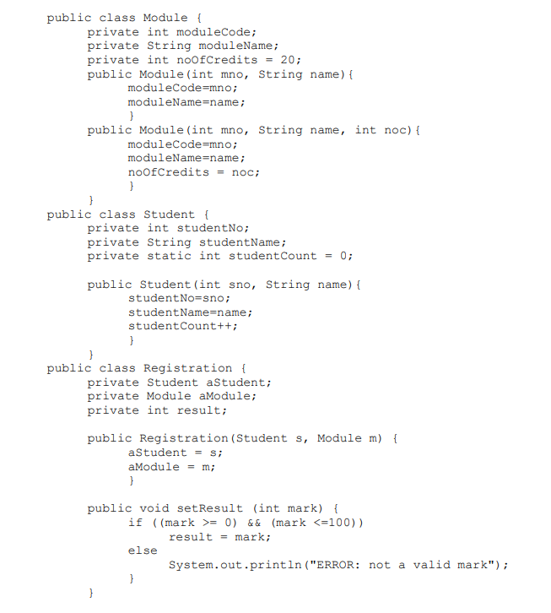

You can assume that other appropriate setter and getter methods have been defined, but are not fully documented here and do not need to be included in the class diagram **[10 marks**]

**Question 2**

a) Write a Java program that takes a year from user and print whether that year is a leap year or not.

*Test Data*  
Input the year: 2020  
*Expected Output*:  
2020 is a leap year **[10 marks**]

b) Study the excerpt from the Javadoc below and write a program that checks whether a file called Exam2023.docx located in a folder called GZUExams in the drive C is hidden or not **[10 marks**]

**Javadoc**

**java.​io.​File**

public boolean **isHidden**()

Tests whether the file named by this abstract pathname is a hidden file. The exact definition of *hidden* is system-dependent. On UNIX systems, a file is considered to be hidden if its name begins with a period character ('.'). On Microsoft Windows systems, a file is considered to be hidden if it has been marked as such in the filesystem.

**Returns:**

true if and only if the file denoted by this abstract pathname is hidden according to the conventions of the underlying platform

**Throws:**

SecurityException - If a security manager exists and its SecurityManager.checkRead(java.lang.String) method denies read access to the file

**Question 3**

a) Give three differences between an interface and an abstract class in Java. [3 marks]

b) A novice programmer writes the following code in order to be able to completely clone an object of type Car.

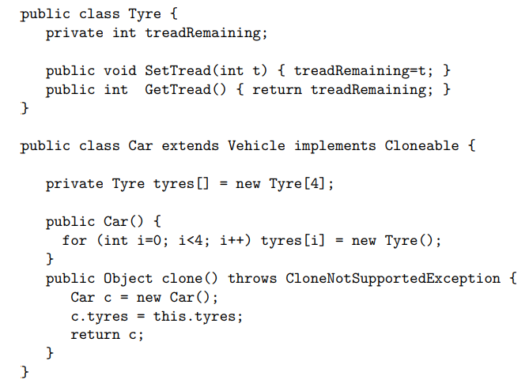

1. Explain what it means for the treadRemaining field to be private. Explain why it is good programming practice for such fields to be private. **[3 marks]**
2. Identify the type of interface that Cloneable is. What is the defining characteristic of such interfaces? **[2 marks]**
3. Identify and explain two reasons why this code may not function as intended. [4 marks]
4. Rewrite the code to address the problems you have identified and allow Car objects to be fully cloned. **[8 marks]**

**Question 4**

a) Write a Java GUI application called *MapsDistanceEstimator* to compute the distance between two points on the surface of earth. You may use the following Swing components

JPanel for the components layout

JText for user input

JLabel for displaying the results as text

JButtons for computing the distance between two points.  **[20 marks]**

**Distance between the two points [ (x1,y1) & (x2,y2)] d** = radius * arccos(sin(x1) * sin(x2) + cos(x1) * cos(x2) * cos(y1 - y2))  
**Radius of the earth r** = 6371.01 Kilometers

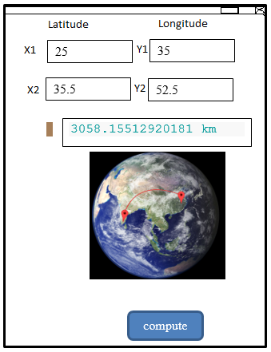*Test Data:*

## **Question 5**

1. Distinguish between an Exception and an Error. **[4 marks]**
2. Give one example of each  **[2 marks]**
3. What will be the output of the program?

try

{

int x = 0;

int y = 5 / x;

}

catch (Exception e)

{

System.out.println("Exception");

}

catch (ArithmeticException ae)

{

System.out.println(" Arithmetic Exception");

}

System.out.println("finished"); **[4 marks]**

1. Explain the output of the following program?

public class X

{

public static void main(String [] args)

{

try

{

badMethod();

System.out.print("A");

}

catch (Exception ex)

{

System.out.print("B");

}

finally

{

System.out.print("C");

}

System.out.print("D");

}

public static void badMethod()

{

throw new Error(); /* Line 22 */

}

}

**[5 marks]**

1. What will be the output of the program?

int I = 0;

outer:

while (true)

{

I++;

inner:

for (int j = 0; j < 10; j++)

{

I += j;

if (j == 3)

continue inner;

break outer;

}

continue outer;

}

System.out.println(I);

**[5 marks]**

**Question 1**

Consider the following Java class that is intended to represent a specific day in an eight-week University term.

public class TermDay {

public int day; // The day of the week as a number 0-6

public int week; // The week of the term as a number 0-7

};

a) Create a class EncapsulatedTermDay, which applies the principles of data encapsulation as an alternative to TermDay. Your modified class should throw an exception if an invalid day of the week or week number is specified**. [6 marks]**

b) The use of two int variables to represent the day and the week requires 64 bits of storage. How many bits are actually required? Adapt EncapsulatedTermDay class to achieve the same functionality using only one-member variable of a primitive type. You should justify your choice of type. **[4 marks]**

c) Explain what the terms coupling and cohesion mean in an object-oriented system. Show how they are implemented in java programming language **[10 marks]**

**Question 2**

a) Show how threads ways can be implemented in java. **[5 marks]**

b) Define the terms serialization and deserialization of objects in Java? **[4 marks]**

c) What interface is implemented in java to make the object serializable? **[1 mark]**

d) Build a SimpleSleepThread class by implementing Runnable. Create an object Thread and start the thread. In run method, let the thread sleep for 10000ms. Display strings before and after the thread sleep. **[10 marks]**

**Question 3**

1. Distinguish between an Exception and an Error. **[4 marks]**
2. Give one example of each  **[2 marks]**
3. What will be the output of the program?

try

{

int x = 0;

int y = 5 / x;

}

catch (Exception e)

{

System.out.println("Exception");

}

catch (ArithmeticException ae)

{

System.out.println(" Arithmetic Exception");

}

System.out.println("finished"); **[4 marks]**

1. Explain the output of the following program?

public class S

{

public static void main(String [] args)

{

try

{

badMethod();

System.out.print("A");

}

catch (Exception ex)

{

System.out.print("B");

}

finally

{

System.out.print("C");

}

System.out.print("D");

}

public static void badMethod()

{

throw new Error(); /* Line 22 */

}

}

**[5 marks]**

1. What will be the output of the program?

int z = 0;

outer:

while (true)

{

z++;

inner:

for (int w = 0; w < 10; w++)

{

z += w;

if (w == 5)

continue inner;

break outer;

}

continue outer;

}

System.out.println(z);

**[5 marks]**

**Question 4**

a) Write a java program that uses the URL class and the openStream() method to read and write interactively the contents of GZU website, *www.gzu.ac.zw*. Insert line comments, on each line to explain your code. **[20 marks]**

## **Question 5**

a) Write a code for server application, that is supposed to belistening for http requestson port 2022 and sends a message, *“Welcome to Socket-Server Programming Exam*” to client when a socket is created. NB. Do not write code for the client program. **[10 marks]**

b) Explain the following object-oriented programming concepts. Your explanation should **show** program code excerpt as the concept is implemented using the Java language

1. Abstraction
2. Interface
3. Inheritance
4. Polymorphism
5. Thread **[10 marks]**

## **Question 6**

a) Differentiate between the following:

1. Function overloading and function overriding [5]
2. Constructor overloading and operator overloading **[5]**

b) What is polymorphism? Write a program using polymorphism in which user enters the number if the number is positive and the number is also even, then print the cube of the number and if the number is odd and negative then print the square of the number.[10]

**Question 1**

a) Write a Java program that prompts the user to input his/her details on the console and then print the details on a separate line.  The output should include   
StudentID, firstname, surname, program and year of enrolment. **[10 marks]**

b) Write a java program that retrieves the IP address of a local computer and ip address of studentportal.gzu.ac **[10 marks]**

**Question 2**

a) Define the *package* as it is used in Java **[2 marks]**

b) List and explain 3 *access modifiers* used in Java. **[6 marks]**

c) Define a java class Student in a package called HCS124 that stores the *studentName, program*, *PIN and* a class variable *totalNumberOfStudents* which retains the total number of student objects instantiated. You should define a default constructor. **[2 marks]**

d) Write Java applet program that writes the words “Java Rules”. **[2 marks]**

e) Write the html file that you would use to open the applet program in the browser or appletviewer. **[5marks]**

**Question 3**

1. If a database server takes more than 200 connections, it may not function properly and cause unpredictable system failure. Define a Datasource class using a singleton design pattern that uses a fixed thread pool of 200 to make connections to a database system and return a connection object that can be used to connect to this database. The class method getConnection() returns the Connection object. **[10 marks]**
2. Distinguish between in **method overloading** and **method overriding** giving examples of class methods in the Java language. You may define your own class to demonstrate your understanding **[6 marks]**
3. Define a constructor in java through use of a code snippet **[4 marks]**

**Question 4**

A group of Open Water Swimmers have found their sport has become popular and now wish to set up a Swimming Club. The Club will be made up of Members, who can register online and have to provide their name, address, contact telephone number and emergency contact name and telephone number.

Each September there is an Annual General Meeting (AGM), where Members can join a Committee to help run the Club.

The Club meets every week at a local lake, where Members can train, or take part in lessons. The lessons are provided by Officials, who have to be qualified. New Officials need to register online and provide evidence of what qualifications they hold.

In addition to the weekly meetings, the Club runs a series of swims to be held on the first Saturday of each month at a different location. A Member can nominate a potential outdoor place, which can be a river, lake or sea and provide a classification of whether it is easy, moderate or strenuous. These will be assessed by the Committee to decide if they are suitable and whether a quota is needed to limit numbers. Suitable locations will be included in an online Diary produced by the Committee.

The Club charges an annual fee, which is due on the 1st January of each year. A month after this, the Committee will generate an email to remind any Members who have forgotten to pay

a) Draw a Use Case diagram for the Swimming Club. **[15 marks]**

b) Discuss how Use Case diagrams and scenarios contribute to the development of an object-oriented system. Within your answer include an example scenario from the Swimming Club. **[5 marks]**

## **Question 5**

a) Explain the following object-oriented programming concepts. Your explanation should **show** program code excerpt as the concept is implemented using the Java language

1. Encapsulation
2. Information hiding
3. Inheritance
4. Polymorphism
5. Abstraction **[10 marks]**

b) You have been asked to maintain an existing system and have been presented with the object-oriented code below. To aid your understanding of the system draw a class diagram to represent this information:



You can assume that other appropriate setter and getter methods have been defined, but are not fully documented here and do not need to be included in the class diagram **[10 marks**]